Defect 1: In RecipeBook, the deleteRecipe method does not delete a recipe, just the data for the recipe. As far as the program is considered, there has been no change in the number of recipes in the recipe book.

Failed test unit: testAddRecipe6

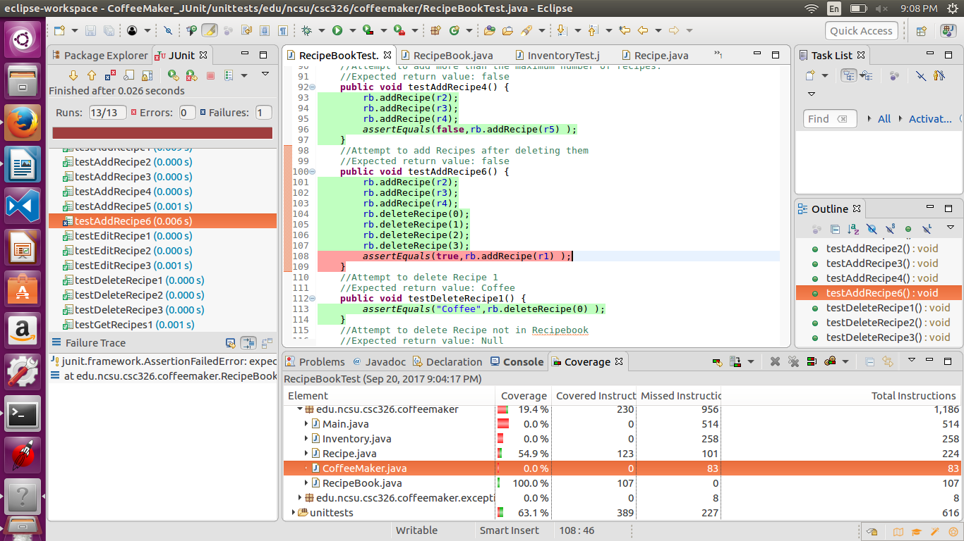

Code causing defect: deleteRecipe method

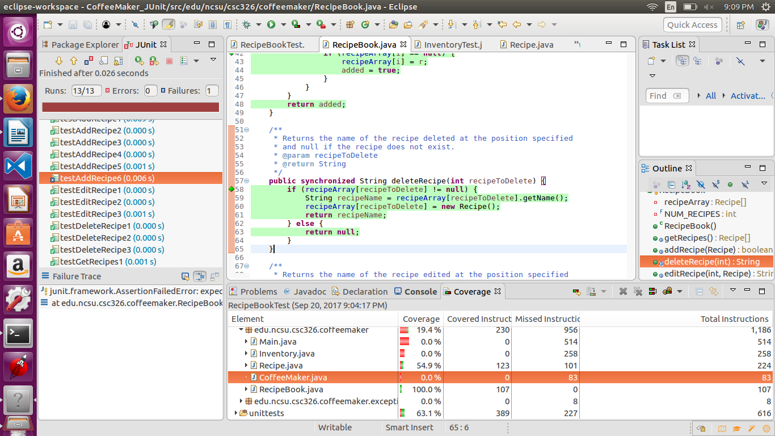

Defect 1 Solution: When recipe is removed, instead of replacing it with a blank recipe, replace it with null.

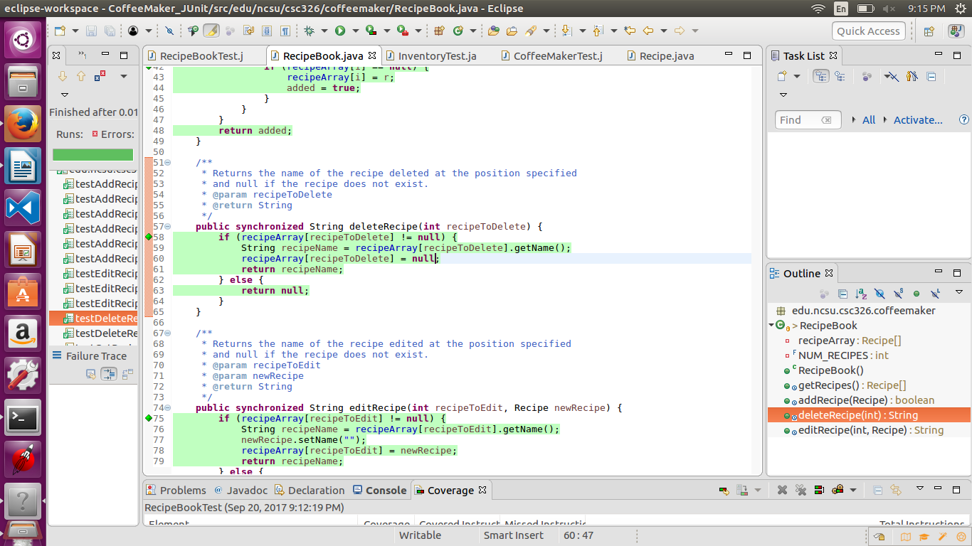

TestAddRecipe6 now passes

